1.Prepare adobe forms interface structure header and item in **SE11**

Item structure

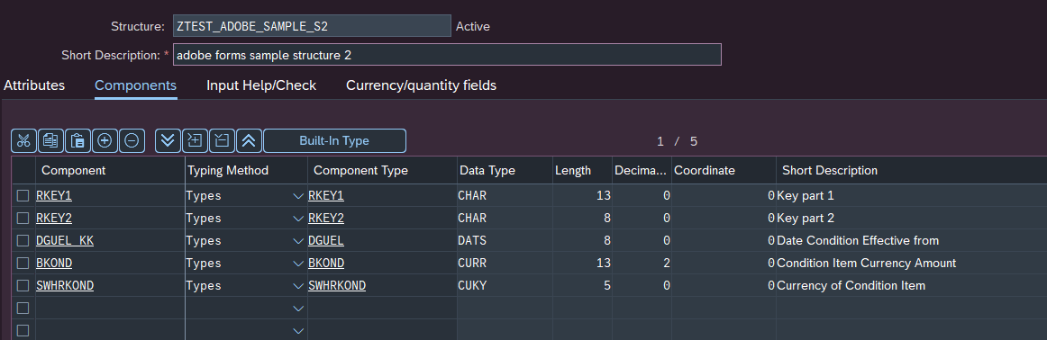

Create Item table type

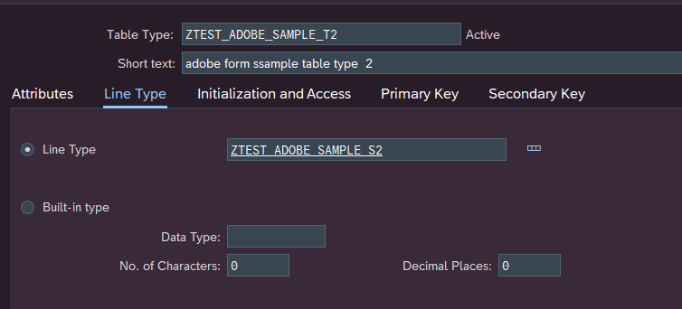

**Header structure with ITEM TABLE TYPE ASSIGNED**

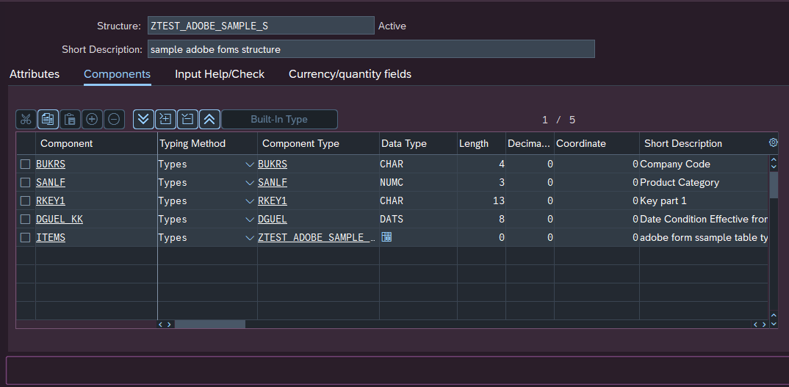

Create Header Table type

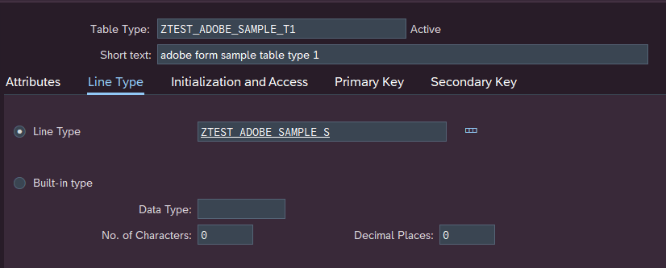

2. Create Adobe form Interface and assign the created Table type

Goto SFP transaction and create interface

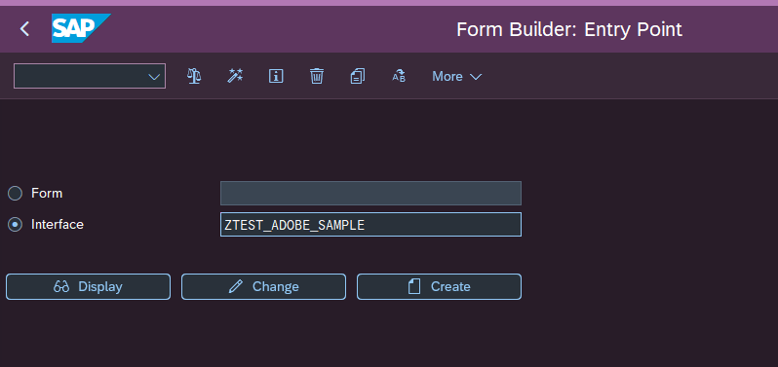

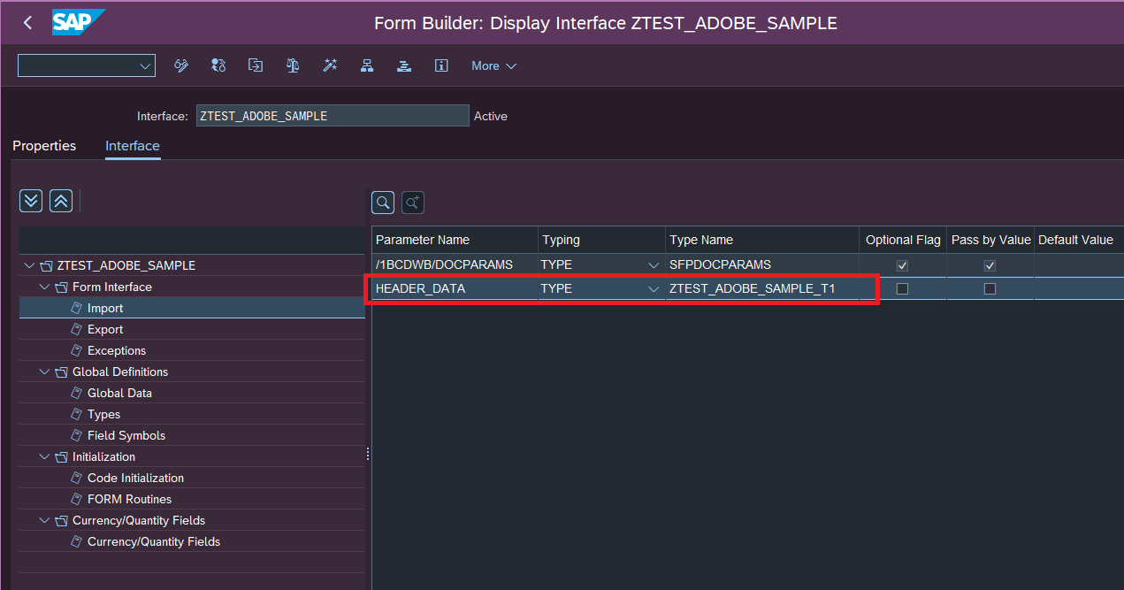

3. Create ADOBE Forms Driver Program with appropriate logic and sample code as follows

*&---------------------------------------------------------------------*  
*& Report ZTEST_ADOBE_SAMPLE  
*&---------------------------------------------------------------------*  
*&  
*&---------------------------------------------------------------------*  
REPORT ztest_adobe_sample.  
  
DATA: gd_path TYPE string.  
  
DATA : gt_header TYPE STANDARD TABLE OF ztest_adobe_sample_s,  
       gt_item   TYPE STANDARD TABLE OF ztest_adobe_sample_s2,  
       gs_header TYPE ztest_adobe_sample_s,  
       gs_item   TYPE ztest_adobe_sample_s2.  
  
DATA : gv_conn TYPE rfcdest.  
  
PARAMETERS : p_rkey1 TYPE rkey1 OBLIGATORY.  
  
  
SELECTION-SCREEN: BEGIN OF BLOCK b1 WITH FRAME TITLE TEXT-001.  
  
  PARAMETERS : " ADOBE FORM PREVIEW  
    rad1   RADIOBUTTON GROUP r1 DEFAULT 'X' USER-COMMAND ccc,  
  
    " SAVE DIALOG DIRECTORY POPUP  
    rad2   RADIOBUTTON GROUP r1,  
  
    " ENTER DIRECOTRY IN SELECTION SCREEN TO SAVE PDF FILES TO THE DIRECTORY  
    rad3   RADIOBUTTON GROUP r1,  
  
    p_path TYPE rlgrap-filename OBLIGATORY MODIF ID ccc.  
SELECTION-SCREEN: END OF BLOCK b1.  
  
  
AT SELECTION-SCREEN ON VALUE-REQUEST FOR p_path.  
  
  CALL METHOD cl_gui_frontend_services=>directory_browse  
    EXPORTING  
      window_title    = 'File Directory'  
      initial_folder  = 'C:'  
    CHANGING  
      selected_folder = gd_path.  
  CALL METHOD cl_gui_cfw=>flush.  
  
  CONCATENATE gd_path '' INTO p_path.  
  
AT SELECTION-SCREEN OUTPUT.  
  
  IF rad1 = 'X'.  
    LOOP AT SCREEN.  
      IF screen-group1 = 'CCC'.  
        screen-active = '0'.  
        MODIFY SCREEN.  
      ENDIF.  
    ENDLOOP.  
  
  ELSEIF rad2 = 'X'.  
    LOOP AT SCREEN.  
      IF screen-group1 = 'CCC'.  
        screen-active = '0'.  
        MODIFY SCREEN.  
      ENDIF.  
    ENDLOOP.  
  
  ELSEIF rad3 = 'X'.  
    LOOP AT SCREEN.  
      IF screen-group1 = 'CCC'.  
        screen-active = '1'.  
        MODIFY SCREEN.  
      ENDIF.  
    ENDLOOP.  
  ENDIF.  
  
  
INITIALIZATION.  
  gv_conn = 'ADS'.  
  MOVE cl_fp=>get_ads_connection( ) TO gv_conn.  
  
START-OF-SELECTION.  
  
  SELECT * FROM vzzkoko INTO TABLE @DATA(lt_koko)  
    WHERE rkey1 EQ @p_rkey1.  
  IF sy-subrc EQ 0.  
    SELECT * FROM vzzkopo INTO TABLE @DATA(lt_kopo)  
      FOR ALL ENTRIES IN @lt_koko WHERE rkey1 EQ @lt_koko-rkey1.  
  ENDIF.  
  
  IF lt_kopo IS NOT INITIAL.  
    LOOP AT lt_kopo INTO DATA(ls_kopo).  
      MOVE-CORRESPONDING ls_kopo TO gs_item.  
      gs_item-rkey2 = sy-tabix.  
      APPEND gs_item TO gt_item.  
      CLEAR : gs_item, ls_kopo.  
    ENDLOOP.  
  
    READ TABLE lt_koko INTO DATA(ls_koko) INDEX 1.  
    IF sy-subrc EQ 0.  
      MOVE-CORRESPONDING ls_koko TO gs_header.  
      gs_header-items = gt_item.  
      APPEND gs_header TO gt_header.  
    ENDIF.  
  ENDIF.  
  
****** ADOBE FORM processing  
* VARIABLES declaration  
  
  DATA: lv_fmname       TYPE fpname,  
        lv_sign         TYPE xstring,  
        ls_outputparams TYPE sfpoutputparams,  
        ls_docparams    TYPE sfpdocparams,  
        ls_pdf          TYPE fpformoutput  ##NEEDED.  
  
  DATA:lt_data            TYPE STANDARD TABLE OF tabl1024,  
       lo_pdf_merger      TYPE REF TO cl_rspo_pdf_merge,  
       lt_pdf_table       TYPE tfpcontent,  
       lv_file            TYPE string,  
       lv_path            TYPE string,  
       lv_file_name       TYPE string,  
       lv_merged_document TYPE xstring,  
       lv_len             TYPE i,  
       lv_rc              TYPE i VALUE 0,  
       result             TYPE sfpjoboutput,  
       l_spoolid          TYPE rspoid,  
       lv_filename        TYPE string VALUE 'ADOBE_SAMPLE'.  
  
  
* COSTANTS DECLARATION  
  CONSTANTS : lc_form_name TYPE fpname VALUE 'ZTEST_ADOBE_SAMPLE'.  
  
* OUTPUT PRINTER SETTINGS  
  ls_outputparams-dest     = 'LP01'. "Depends on user settings  
  
  IF rad1 NE abap_true.  
    ls_outputparams-nodialog = abap_true.  
    ls_outputparams-getpdf   = 'M'.  
    ls_outputparams-assemble = 'S'.  
    ls_outputparams-bumode   = 'M'.  
    ls_outputparams-reqnew   = abap_true.  
  ENDIF.  
  
  DATA(lt_fin) = lt_pdf_table.  
  CLEAR lt_fin.  
  
  TRY.  
      CALL FUNCTION 'FP_FUNCTION_MODULE_NAME'   " Form Processing Generation  
        EXPORTING  
          i_name     = lc_form_name  
        IMPORTING  
          e_funcname = lv_fmname.  
    CATCH  cx_fp_api_usage ##NO_HANDLER .  
    CATCH  cx_fp_api_repository ##NO_HANDLER .  
    CATCH  cx_fp_api_internal ##NO_HANDLER .  
  ENDTRY.  
  
  
  ls_outputparams-connection = gv_conn.  
* Form Processing: Call Form  
  CALL FUNCTION 'FP_JOB_OPEN'  
    CHANGING  
      ie_outputparams = ls_outputparams  
    EXCEPTIONS  
      cancel          = 1  
      usage_error     = 2  
      system_error    = 3  
      internal_error  = 4  
      OTHERS          = 5.  
  IF sy-subrc <> 0.  
    CLEAR ls_outputparams.  
  ENDIF.  
  
  ls_docparams-langu   = 'D'.  
  ls_docparams-country = 'DE'.  
  
  CALL FUNCTION lv_fmname  
    EXPORTING  
      /1bcdwb/docparams  = ls_docparams  
*     iv_sign            = lv_sign  
      header_data        = gt_header  
    IMPORTING  
      /1bcdwb/formoutput = ls_pdf  
    EXCEPTIONS  
      usage_error        = 1  
      system_error       = 2  
      internal_error     = 3  
      OTHERS             = 4.  
  IF sy-subrc <> 0.  
* Implement suitable error handling here  
  ENDIF.  
  
  
*&---- Close the spool job  
  CALL FUNCTION 'FP_JOB_CLOSE'  
    IMPORTING  
      e_result       = result  
    EXCEPTIONS  
      usage_error    = 1  
      system_error   = 2  
      internal_error = 3  
      OTHERS         = 4.  
  IF sy-subrc <> 0.  
    CLEAR ls_pdf.  
  ENDIF.  
  
  
  IF rad1 EQ abap_true.  
* Check the result.  
    IF result-userexit IS INITIAL.  
      IF result-spoolids IS INITIAL.  
        MESSAGE ID 'PO' TYPE 'E' NUMBER '475'.  
      ELSE.  
        READ TABLE result-spoolids INDEX 1 INTO l_spoolid.  
        MESSAGE ID 'PO' TYPE 'S' NUMBER '622' WITH l_spoolid.  
      ENDIF.  
    ENDIF.  
  
  ENDIF.  
  
  
  IF rad2 EQ abap_true OR  
     rad3 EQ abap_true .  
  
    CALL FUNCTION 'FP_GET_PDF_TABLE'  
      IMPORTING  
        e_pdf_table = lt_pdf_table.  
  
*&&-- Merging different pdf files into one  
    CREATE OBJECT lo_pdf_merger.  
  
    APPEND LINES OF lt_pdf_table TO lt_fin.  
  
* Add documents to attribute table of PDF merger  
    LOOP AT lt_fin INTO DATA(lwa_form).  
      lo_pdf_merger->add_document( lwa_form ).  
    ENDLOOP.  
  
* Call kernel method to do the merge of the specified files.  
    lo_pdf_merger->merge_documents( IMPORTING merged_document = lv_merged_document  
                                                           rc = lv_rc ).  
  
    CALL FUNCTION 'SCMS_XSTRING_TO_BINARY'  
      EXPORTING  
        buffer        = lv_merged_document  
      IMPORTING  
        output_length = lv_len  
      TABLES  
        binary_tab    = lt_data.  
  
  ENDIF.  
  
  
  IF rad2 EQ abap_true.  
  
    lv_filename = lv_filename && '_' && sy-datum && '_' && sy-uzeit.  
    CALL METHOD cl_gui_frontend_services=>file_save_dialog  
      EXPORTING  
        window_title              = 'Save Form'  
        default_extension         = 'pdf'  
        default_file_name         = lv_filename  
        prompt_on_overwrite       = 'X'  
      CHANGING  
        filename                  = lv_file_name  
        path                      = lv_path  
        fullpath                  = lv_file  
      EXCEPTIONS  
        cntl_error                = 1  
        error_no_gui              = 2  
        not_supported_by_gui      = 3  
        invalid_default_file_name = 4  
        OTHERS                    = 5.  
    IF sy-subrc <> 0.  
* Implement suitable error handling here  
      MESSAGE 'PDF Process Error' TYPE 'E'.  
    ENDIF.  
  
  ENDIF.  
  
  
  IF rad2 EQ abap_true OR  
     rad3 EQ abap_true .  
  
  
    IF rad3 EQ abap_true.  
      lv_filename = lv_filename && '_' && sy-datum && '_' && sy-timlo.  
      CONCATENATE p_path '\' lv_filename '.pdf' INTO lv_file.  
    ENDIF.  
  
    CALL METHOD cl_gui_frontend_services=>gui_download  
      EXPORTING  
        bin_filesize            = lv_len  
        filename                = lv_file  
        filetype                = 'BIN'  
      CHANGING  
        data_tab                = lt_data  
      EXCEPTIONS  
        file_write_error        = 1  
        no_batch                = 2  
        gui_refuse_filetransfer = 3  
        invalid_type            = 4  
        no_authority            = 5  
        unknown_error           = 6  
        header_not_allowed      = 7  
        separator_not_allowed   = 8  
        filesize_not_allowed    = 9  
        header_too_long         = 10  
        dp_error_create         = 11  
        dp_error_send           = 12  
        dp_error_write          = 13  
        unknown_dp_error        = 14  
        access_denied           = 15  
        dp_out_of_memory        = 16  
        disk_full               = 17  
        dp_timeout              = 18  
        file_not_found          = 19  
        dataprovider_exception  = 20  
        control_flush_error     = 21  
        not_supported_by_gui    = 22  
        error_no_gui            = 23  
        OTHERS                  = 24.  
    IF sy-subrc IS NOT INITIAL.  
      MESSAGE 'PDF Process Error' TYPE 'E'.  
    ENDIF.  
  
    CLEAR:lv_file,lv_len,lv_path,  
          lv_file_name,lt_data, lt_fin.  
  
  ENDIF.

4. Create adobe form and assign earlier created adobe forms interface

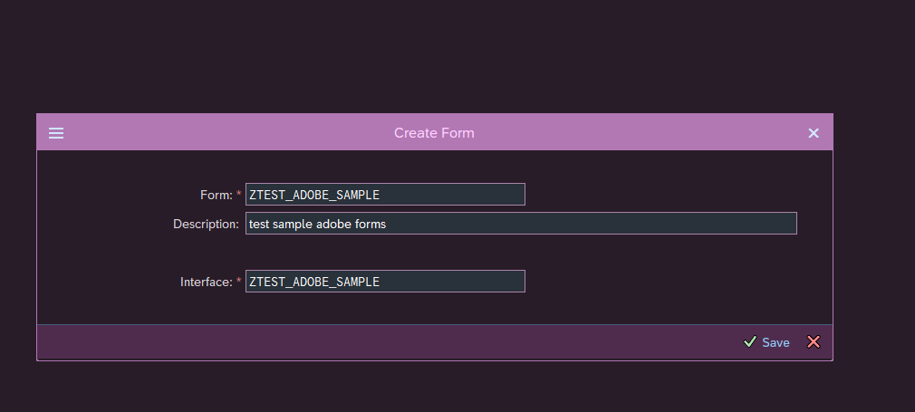

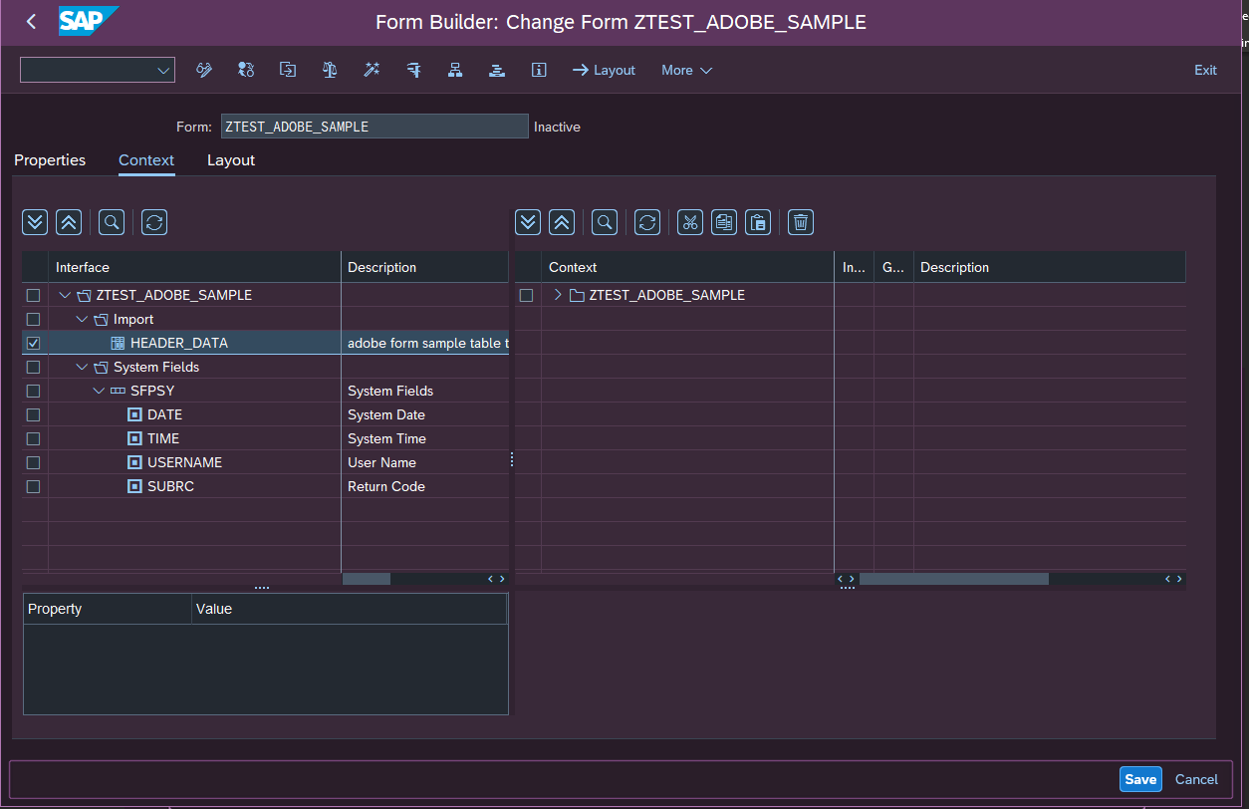

Drag and drop the HEADER_DATA from INTERFACE side to CONTEXT side it may look as follows

Adobe forms configuring is ready next is layout design

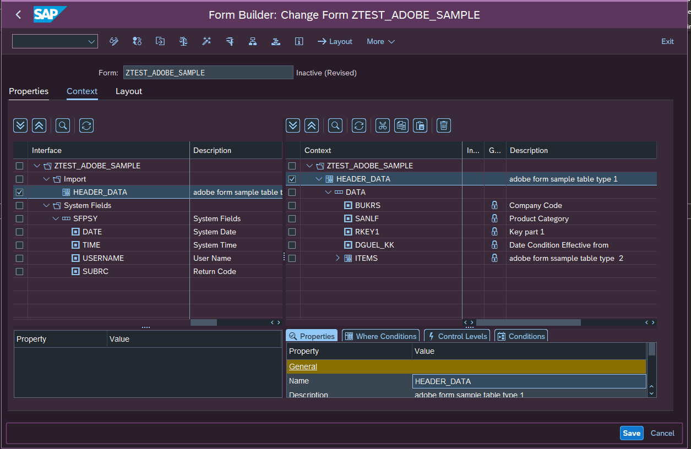

Select the layout tab and start designing

This layout contains subform with **SUBFORM** property – **POSITIONED** so all the text field can be freely placed any where within the layout as shown in this image.

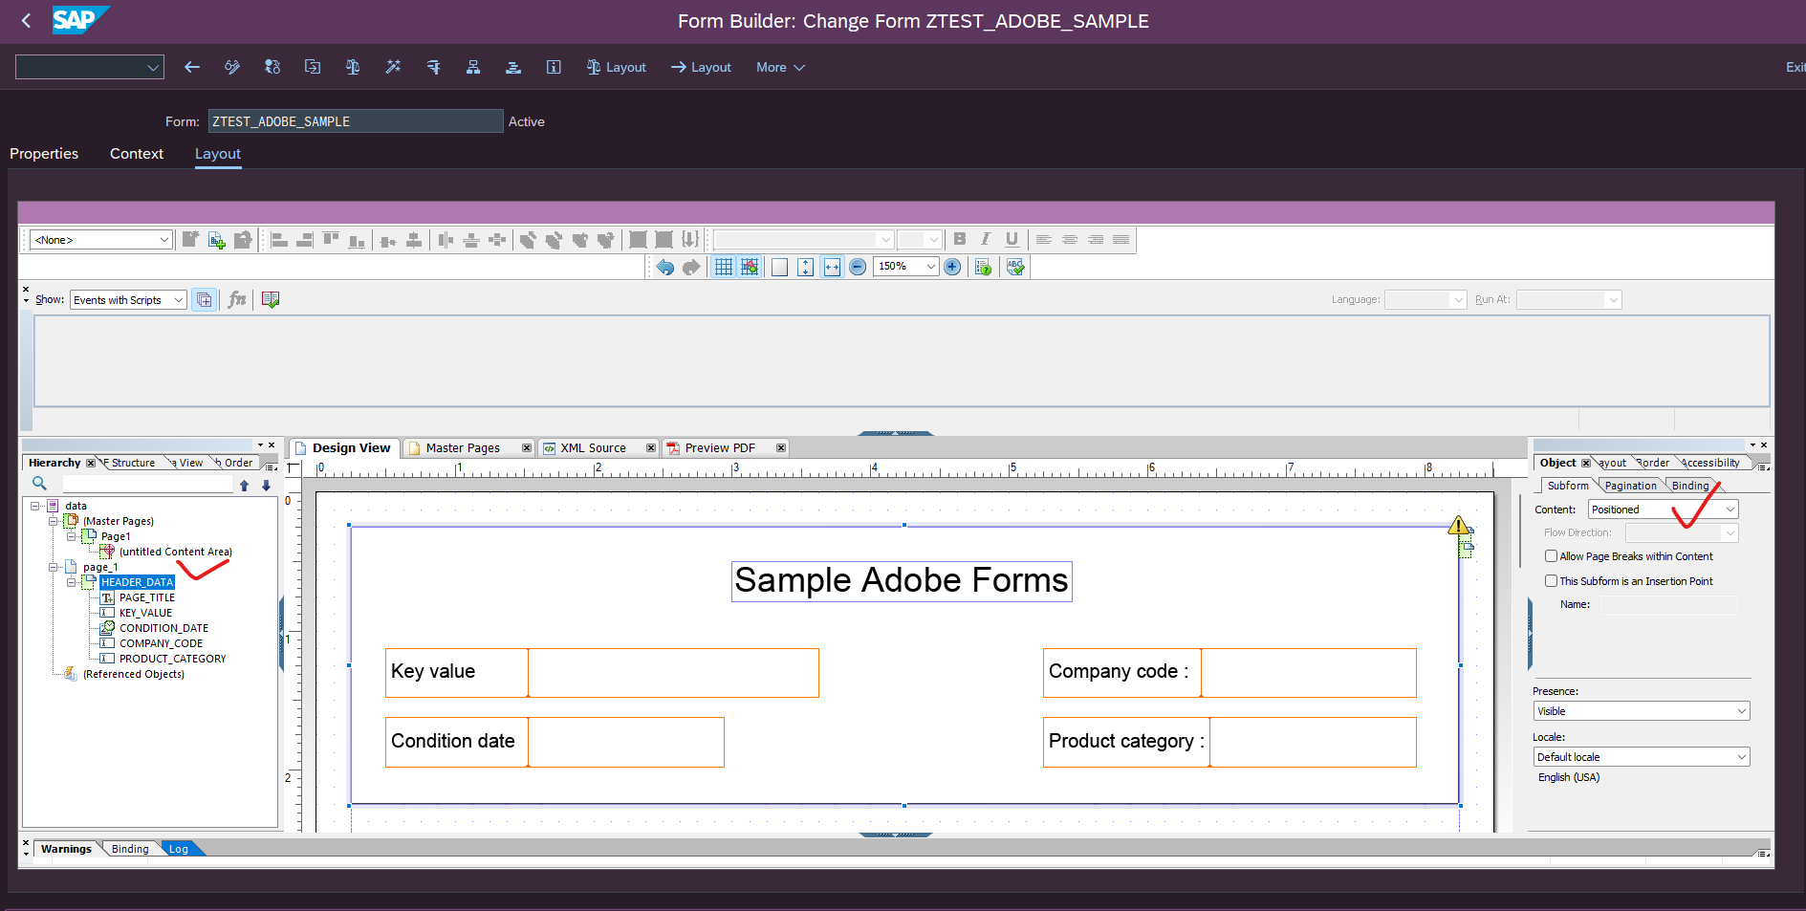

Create a subform with property set as FLOWED.

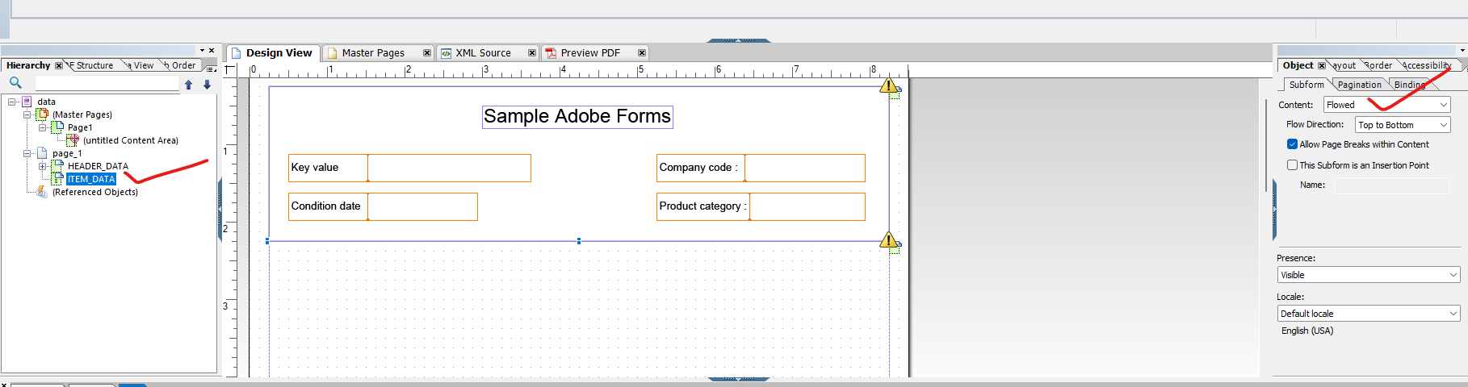

Objects created under **FLOWED** cannot be placed freely it acts like a **SEQUENCE OF STACK**

**This layout property helps to display line item data of a table to be displayed to next page.**

Next go to **DATA VIEW** tab and drag and drop the ITEM structure into the layout

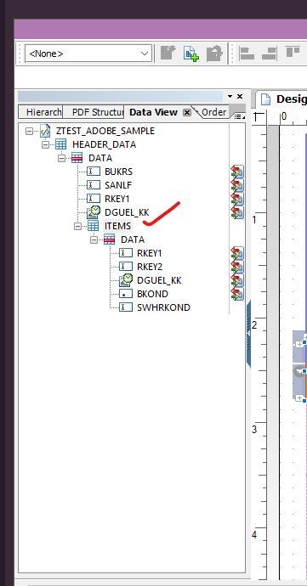

After drag and drop it appears as follows

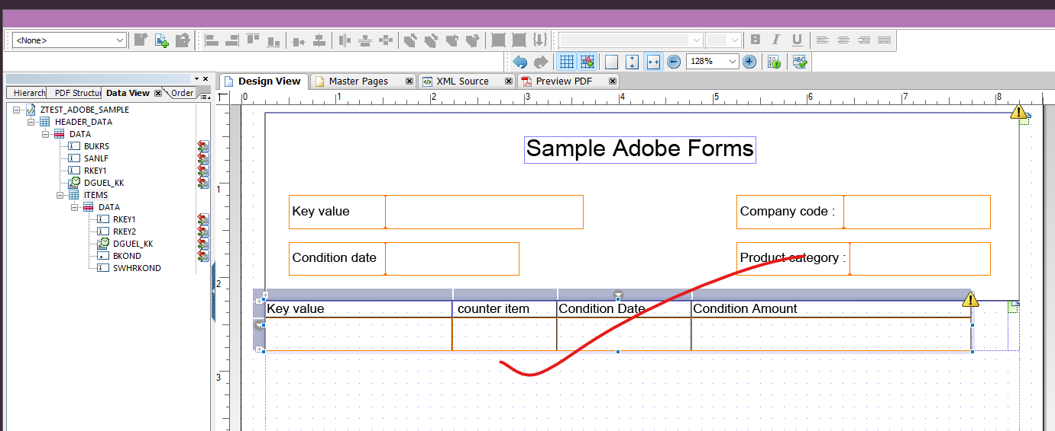

Now go to the **HIERARCHY** tab and select the **PAGE subform object** and set its subform property as **FLOWED**

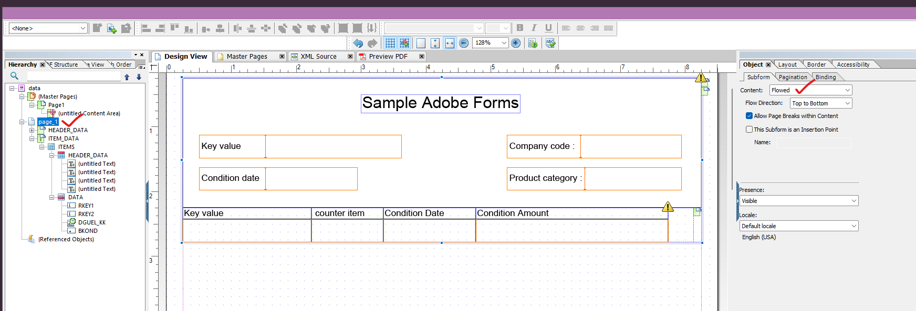

Now go to **ITEM_DATA** sub form and select **PAGINATION** tab and select the Overflow leader property as

Table row item **(TABLE ROW ITEM will display only the line items in subsequent pages )**

**(TABLE ROW HEADER selection will display table header in every page)**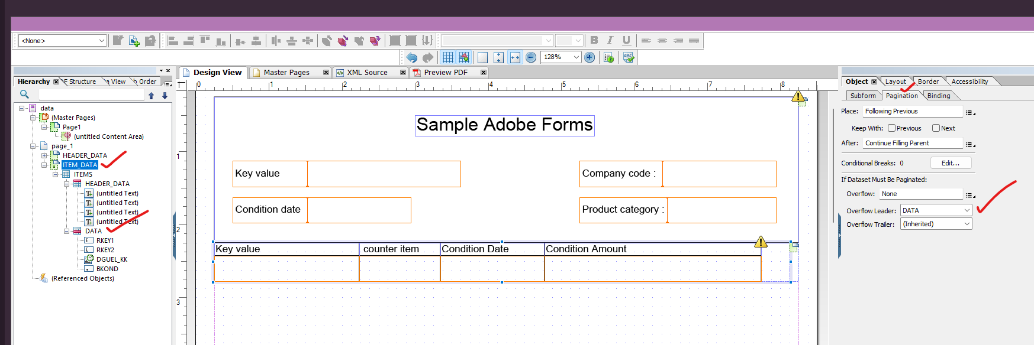

375 line items

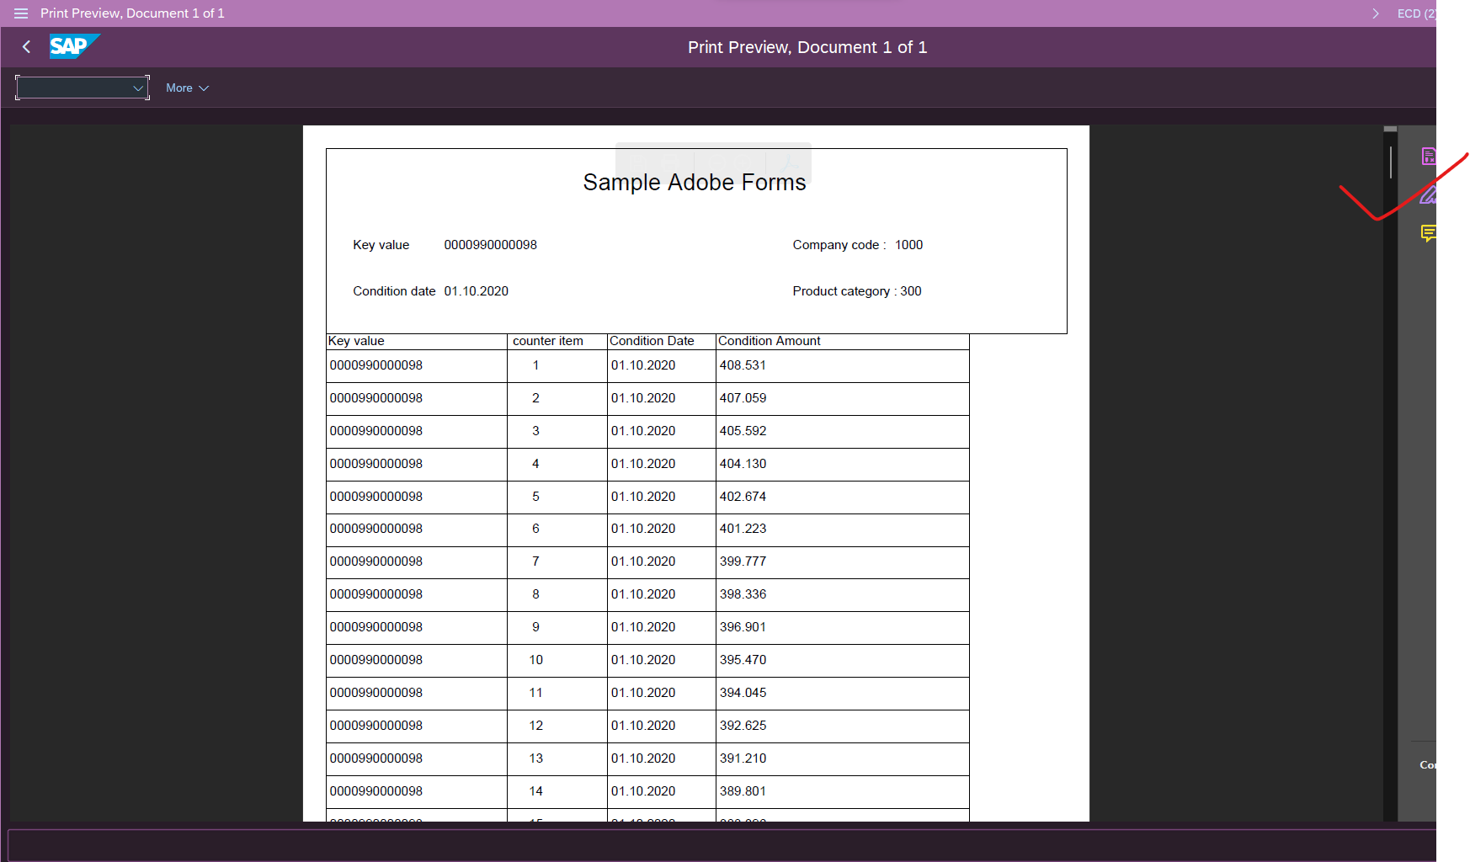

This shows it has 14 pages displayed

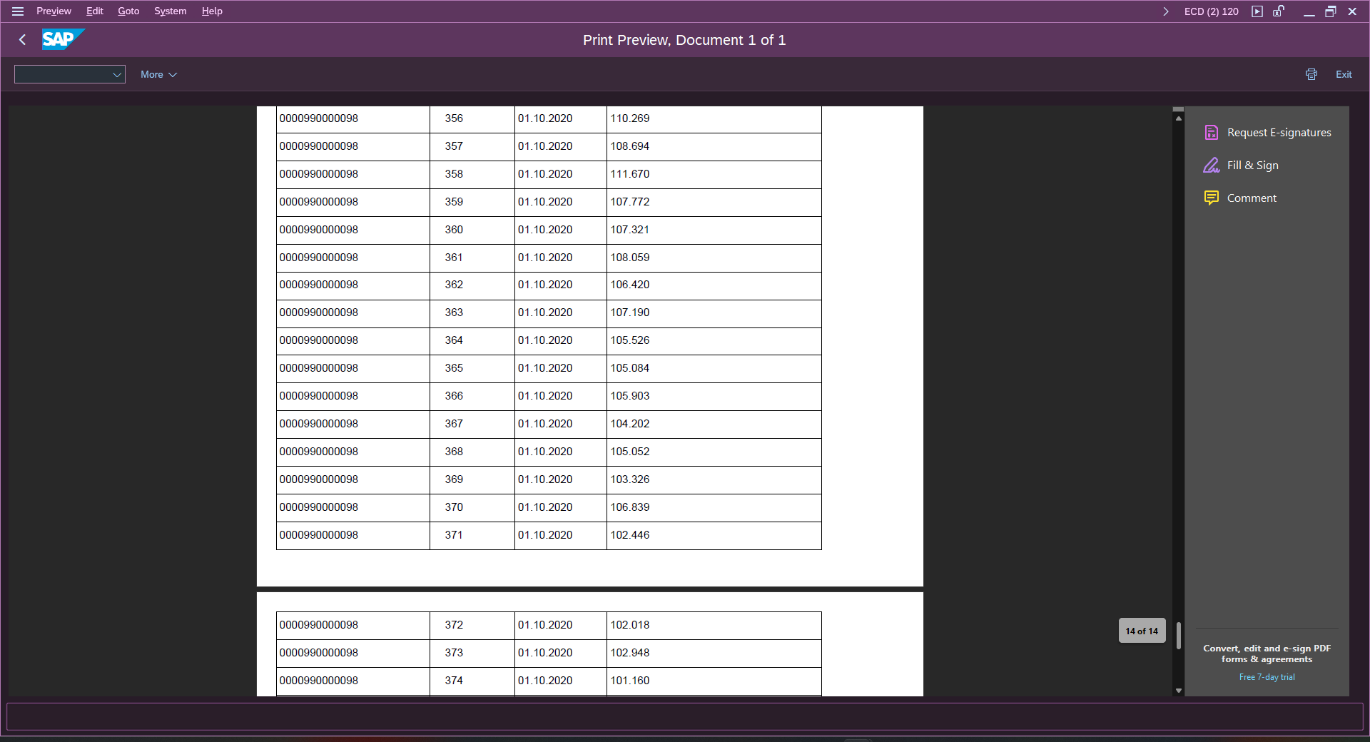

SAMPLE PDF FILE ATTACHED



SAMPLE ADOBE FORM DESIGN FILE AND DATA SCHEMA FILES ATTACHED

